Personnel responsible:
Lead Operator, Assistant Operator

Safety equipment:
Safety Glasses and Safety Shoes are required when working around the dryers. Gloves are required for opening and closing steam valves.

Summary:
A Munters dessicant-wheel type dehumidifier has been installed to dry the air feeding the dryers. This procedure is for starting up, checking, and shutting down the dehumidifier.

Procedure:
- Start Up
    - At the dehumidifier control panel, turn the switch from “Off” to “Manual”.
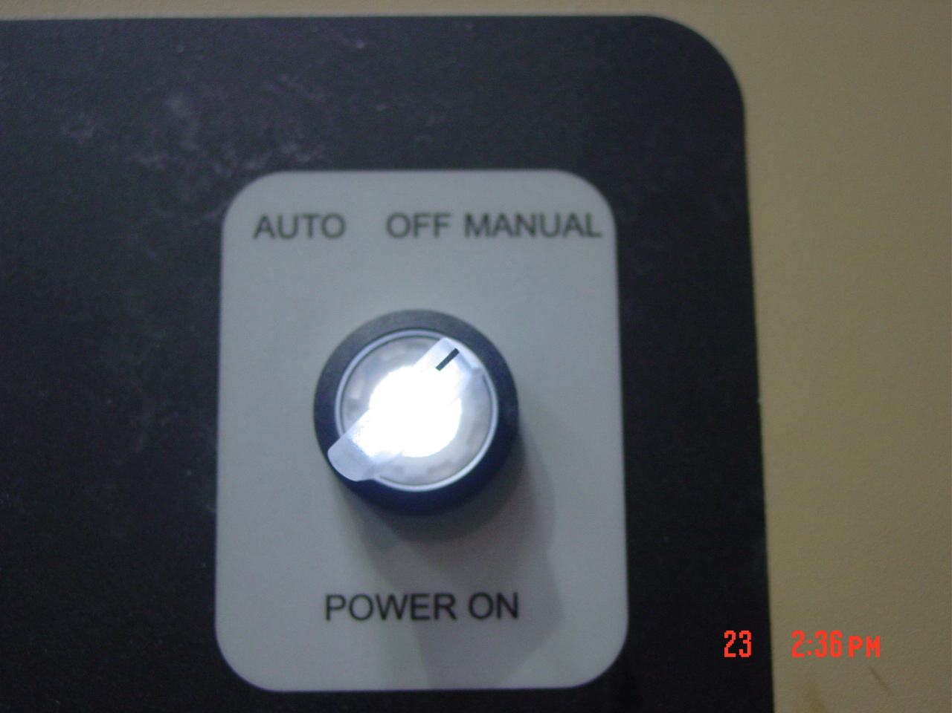

    - With gloves on, open the dehumidifier steam supply valve completely.

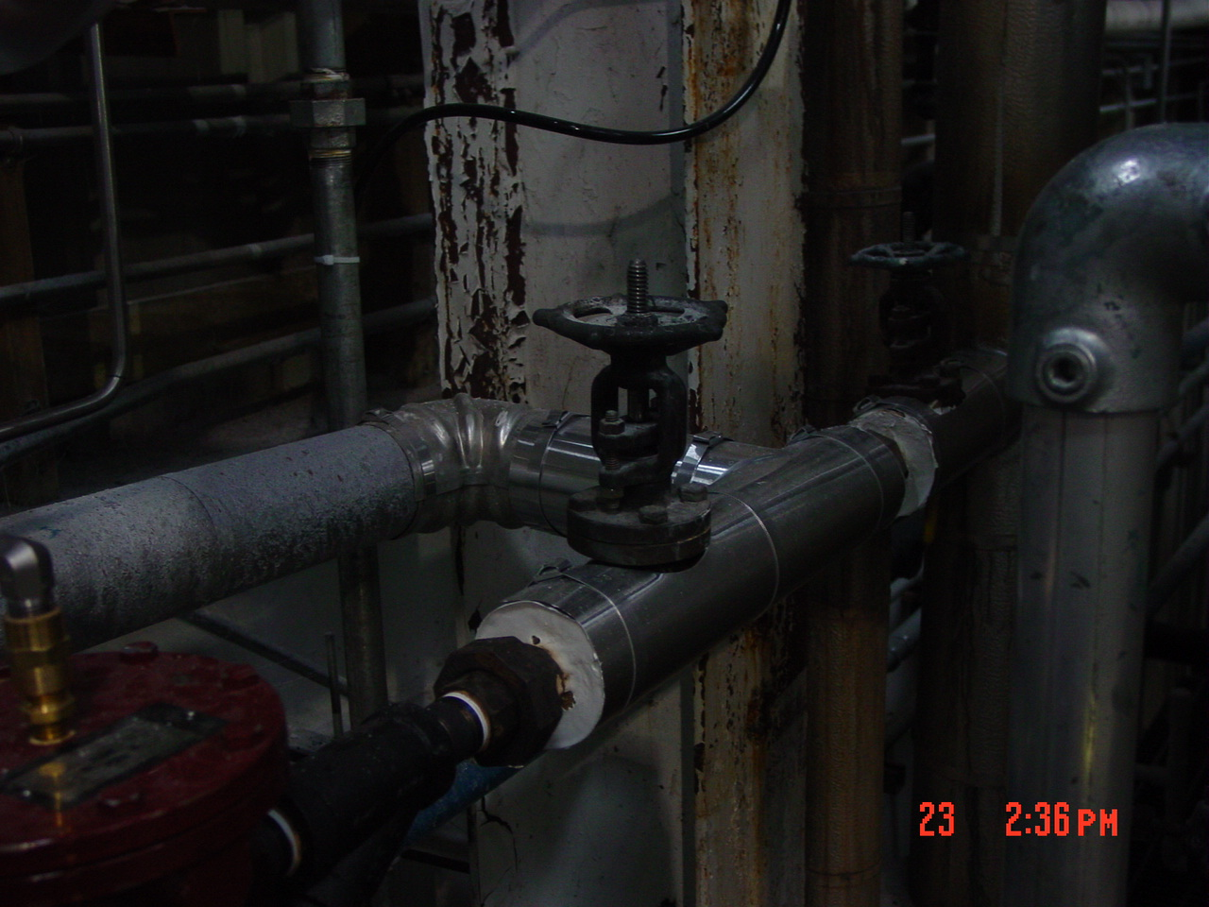

    - Ensure the wall switch for the condensate pump is “On”.

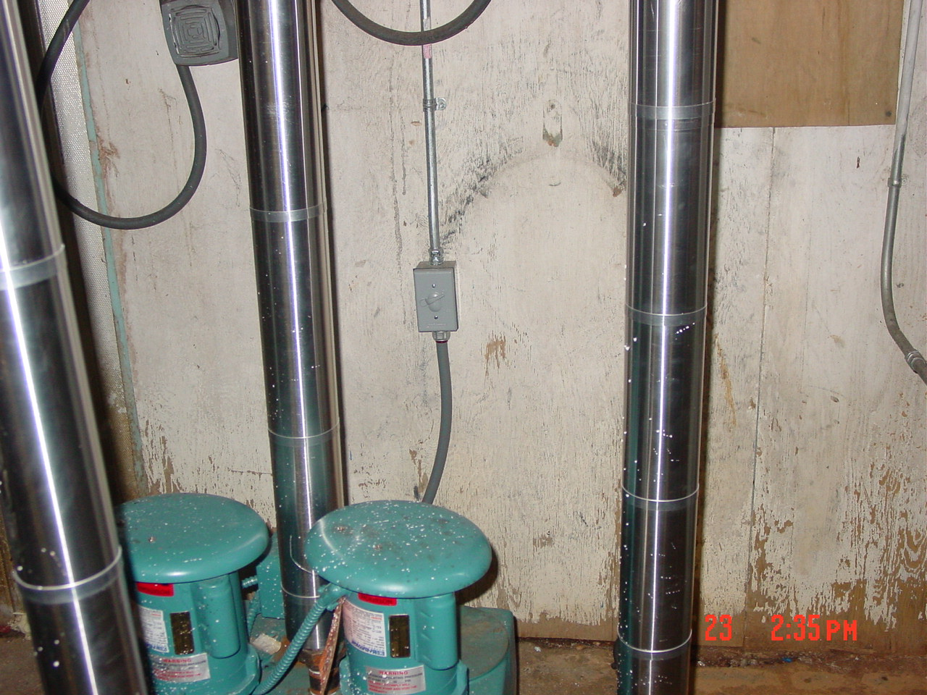
    - Allow the unit to heat up for 20 minutes.
    - Make sure the air is blowing at the back of the dryers.
    - Close the dryer air gates to force the air into the dryers.
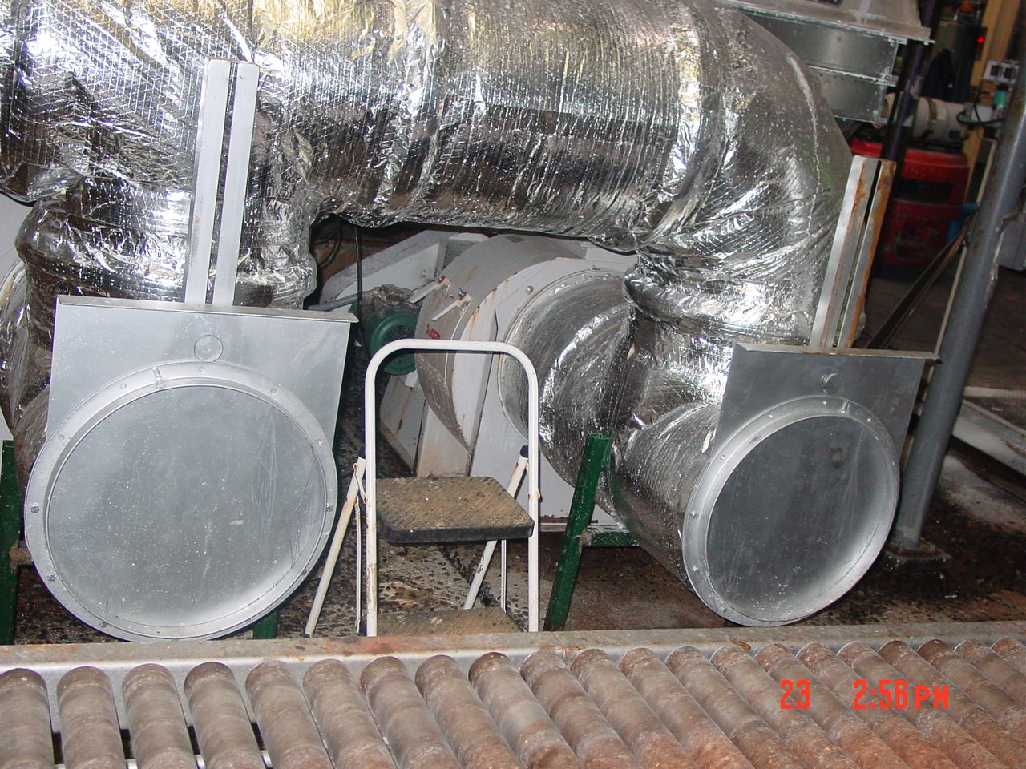

- Operating
    - When doing rounds, ensure the dehumidifier control panel screen says that the unit is “Running”
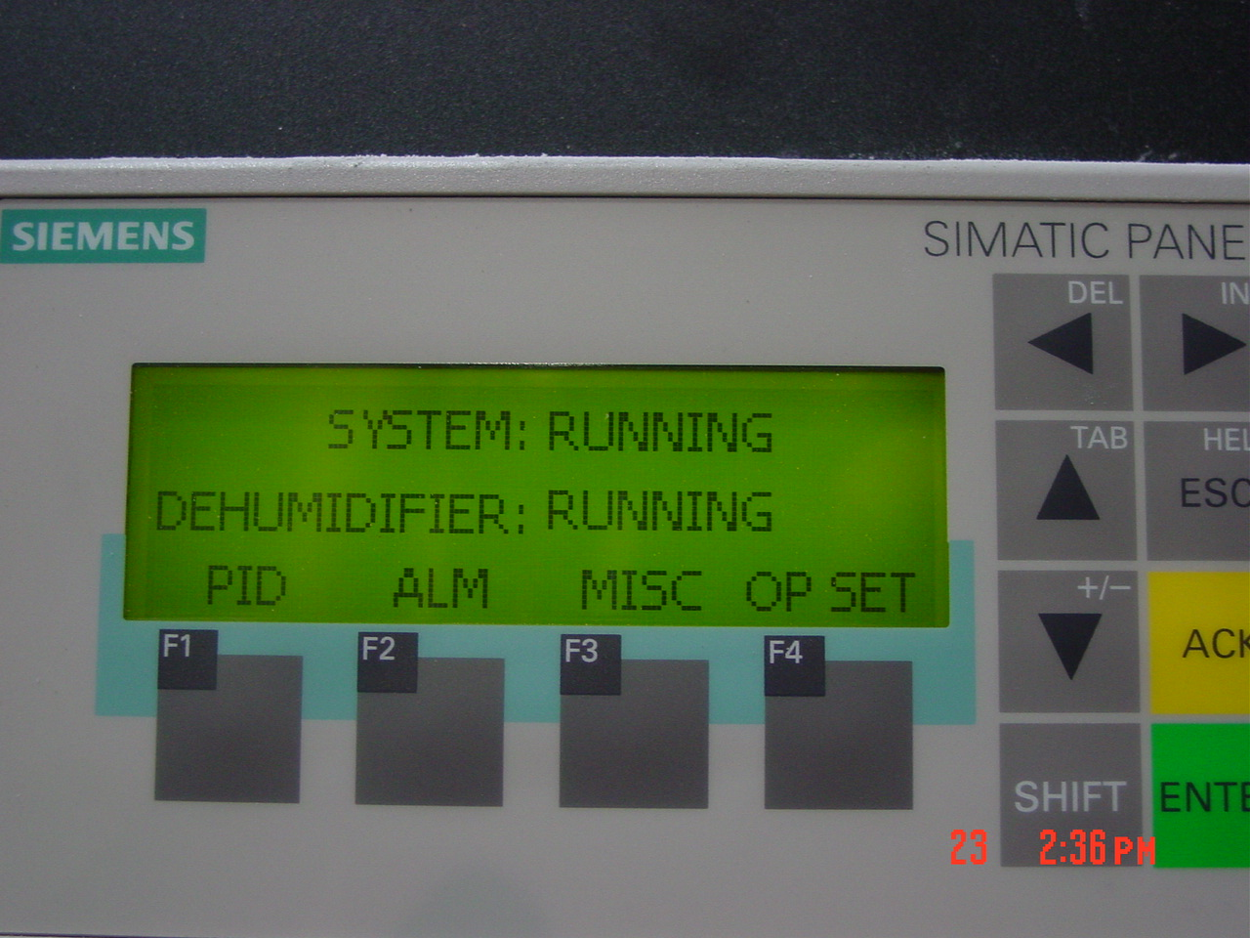

- Shut Down
    - Open the dryer air gates to allow room air into dryers

    - At the dehumidifier control panel, turn the switch from “Manual” to “Off”.

    - With gloves on, close the dehumidifier steam supply valve completely.

TRAINING DOCUMENTATION

 | EMPLOYEE | TITLE | SIGNATURE | DATE
1
2
3
4
5
6
7
8
9
10
11
12
13
14
15
16
17
18

Revision  Number | Revision  Date | Revision  Author | Revision Description
00 | 3/23/2009 | PLO | Original Document

